**Curl GET and POST Method Calls – PHP Example**

<https://phponweb.com/curl-get-post/>

curl is an open source command line tool and library for transferring data with url. It is a good way to send data between websites. It can be making simple HTTP Request, also make complex FTP upload with an authentication, also can make HTTPS requests.

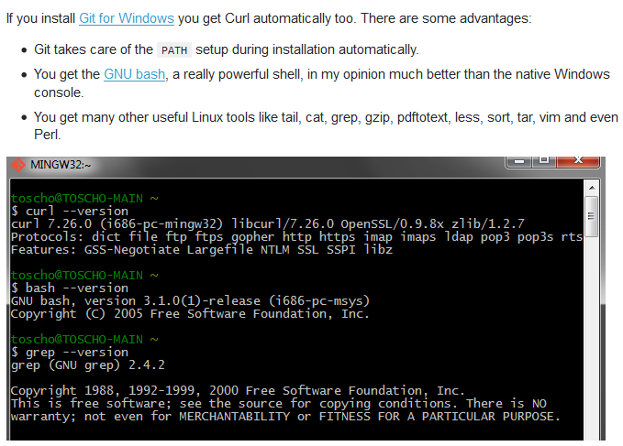

git bash

curl --help

JSONPlaceholder

<https://jsonplaceholder.typicode.com/>

GET

POST

PUT

PATCH

DELETE

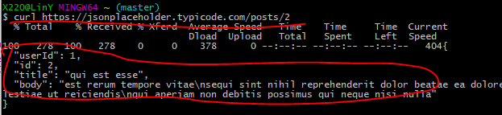

-i

Content-type

-head

-I //flag

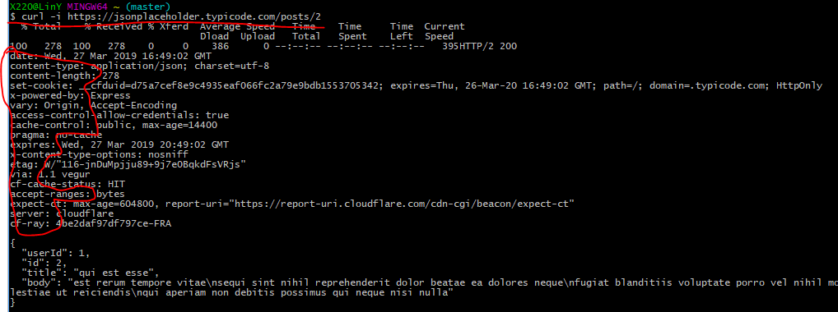

touch hello.txt //create

rm -R hello.txt //remove

write data in test.txt

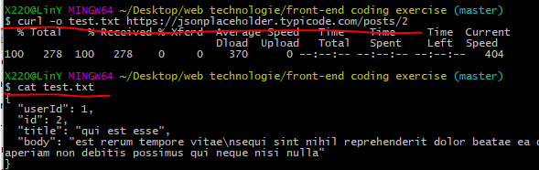

download file

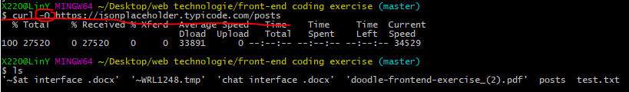

git bash

$ curl -O –limit-rate 1000B http://...

--data

“title=Hello&body=Hello World”

http://

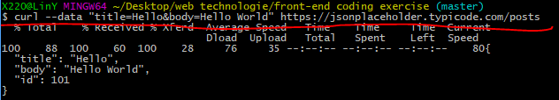

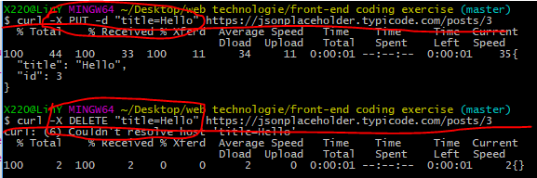

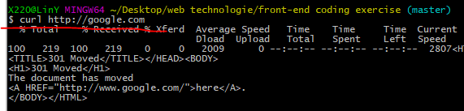

FileZilla